Constant Systematic Error
# Source: AI Source: Provided by: [Data Path: Persons Table -> ID Column: 1, Name_En Column: Motasem Essam] -> From: [ChatGPT] on [7/17/2026]
Constant Systematic Error is a type of systematic error in which every measurement is shifted by the same fixed amount, regardless of the magnitude of the quantity being measured. This constant bias causes all measured values to be consistently higher or lower than the true value by an equal amount.
Constant systematic errors primarily affect measurement accuracy but usually have little effect on precision, because repeated measurements remain consistent.

Definition
# Source: AI Source: Provided by: [Data Path: Persons Table -> ID Column: 1, Name_En Column: Motasem Essam] -> From: [ChatGPT] on [7/17/2026]
Constant Systematic Error is a systematic measurement error that adds or subtracts the same fixed value from every measurement under the same conditions.

Purpose of Studying Constant Systematic Errors
# Source: AI Source: Provided by: [Data Path: Persons Table -> ID Column: 1, Name_En Column: Motasem Essam] -> From: [ChatGPT] on [7/17/2026]
Understanding constant systematic errors helps to:
- Improve measurement accuracy.
- Detect measurement bias.
- Calibrate measuring instruments.
- Correct measurement results.
- Improve quality control.
- Ensure compliance with measurement standards.

Characteristics
# Source: AI Source: Provided by: [Data Path: Persons Table -> ID Column: 1, Name_En Column: Motasem Essam] -> From: [ChatGPT] on [7/17/2026]
Constant systematic errors:
- Are consistent.
- Have a fixed magnitude.
- Affect all measurements equally.
- Produce a constant positive or negative bias.
- Affect accuracy more than precision.
- Can often be corrected by calibration or mathematical adjustment.

Mathematical Representation
# Source: AI Source: Provided by: [Data Path: Persons Table -> ID Column: 1, Name_En Column: Motasem Essam] -> From: [ChatGPT] on [7/17/2026]
If:
- $T$= true value
- $C$= constant systematic error
- $M$= measured value
then:
$$M=T+C$$
where:
- $C>0$indicates a positive bias.
- $C<0$indicates a negative bias.

Example
# Source: AI Source: Provided by: [Data Path: Persons Table -> ID Column: 1, Name_En Column: Motasem Essam] -> From: [ChatGPT] on [7/17/2026]
Suppose a ruler has a calibration error of +0.50 cm.

True Value | Measured Value
10.00 cm | 10.50 cm
25.00 cm | 25.50 cm
80.00 cm | 80.50 cm
Every measurement is 0.50 cm too large.

Another example
# Source: AI Source: Provided by: [Data Path: Persons Table -> ID Column: 1, Name_En Column: Motasem Essam] -> From: [ChatGPT] on [7/17/2026]
A thermometer always reads 2 °C lower than the true temperature.

True Temperature | Measured Temperature
20 °C | 18 °C
35 °C | 33 °C
80 °C | 78 °C
The error remains −2 °C for every measurement.

Causes of Constant Systematic Error
# Source: AI Source: Provided by: [Data Path: Persons Table -> ID Column: 1, Name_En Column: Motasem Essam] -> From: [ChatGPT] on [7/17/2026]
Constant systematic errors commonly arise from:
Zero Error
The measuring instrument does not start at zero.
Example:
A scale reads 0.3 kg when no object is placed on it.

Calibration Error
The instrument has been calibrated incorrectly.
Example:
A ruler manufactured with an incorrect scale.

Instrument Offset
Electronic measuring devices may have a constant electrical offset.

Improper Adjustment
Failure to reset or zero the instrument before measurement.

Identifying Constant Systematic Errors
# Source: AI Source: Provided by: [Data Path: Persons Table -> ID Column: 1, Name_En Column: Motasem Essam] -> From: [ChatGPT] on [7/17/2026]
Constant systematic errors can be detected by:
- Comparing measurements with certified reference standards.
- Calibrating the measuring instrument.
- Measuring objects with known values.
- Comparing results from different calibrated instruments.

Correcting Constant Systematic Errors
# Source: AI Source: Provided by: [Data Path: Persons Table -> ID Column: 1, Name_En Column: Motasem Essam] -> From: [ChatGPT] on [7/17/2026]
A constant systematic error can often be corrected mathematically.
If the constant error is known:
$$\boxed{\text{Corrected Value}=\text{Measured Value}-\text{Constant Error}}$$
Example:
Measured value:
50.60 cm
Known constant error:
+0.60 cm
Corrected value:
$$50.60-0.60=50.00\text{ cm}$$

Applications
# Source: AI Source: Provided by: [Data Path: Persons Table -> ID Column: 1, Name_En Column: Motasem Essam] -> From: [ChatGPT] on [7/17/2026]
Understanding constant systematic errors is important in:
- Engineering
- Manufacturing
- Laboratory measurements
- Scientific research
- Surveying
- Medicine
- Electronics
- Metrology
- Quality assurance

Everyday Examples
# Source: AI Source: Provided by: [Data Path: Persons Table -> ID Column: 1, Name_En Column: Motasem Essam] -> From: [ChatGPT] on [7/17/2026]
Examples include:
- A bathroom scale that always reads 1 kg too high.
- A clock that is always 5 minutes fast.
- A measuring tape whose zero mark is damaged.
- A thermometer with a constant offset.

Common Mistakes
# Source: AI Source: Provided by: [Data Path: Persons Table -> ID Column: 1, Name_En Column: Motasem Essam] -> From: [ChatGPT] on [7/17/2026]
- Confusing constant systematic errors with random errors.
- Assuming repeated measurements remove the error.
- Ignoring instrument calibration.
- Assuming precise measurements are always accurate.
- Forgetting to apply correction factors.

Constant Systematic Error vs. Proportional Systematic Error
# Source: AI Source: Provided by: [Data Path: Persons Table -> ID Column: 1, Name_En Column: Motasem Essam] -> From: [ChatGPT] on [7/17/2026]
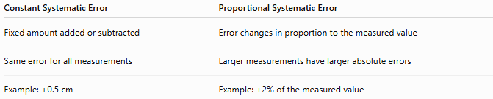
Constant Systematic Error | Proportional Systematic Error
Fixed amount added or subtracted | Error changes in proportion to the measured value
Same error for all measurements | Larger measurements have larger absolute errors
Example: +0.5 cm | Example: +2% of the measured value

Constant Systematic Error vs. Random Error
# Source: AI Source: Provided by: [Data Path: Persons Table -> ID Column: 1, Name_En Column: Motasem Essam] -> From: [ChatGPT] on [7/17/2026]
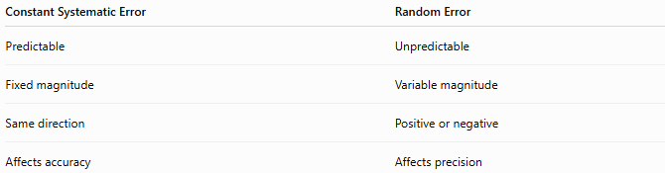
Constant Systematic Error | Random Error
Predictable | Unpredictable
Fixed magnitude | Variable magnitude
Same direction | Positive or negative
Affects accuracy | Affects precision

Constant Systematic Error vs. Gross Error
# Source: AI Source: Provided by: [Data Path: Persons Table -> ID Column: 1, Name_En Column: Motasem Essam] -> From: [ChatGPT] on [7/17/2026]
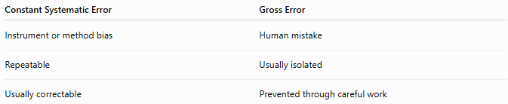
Constant Systematic Error | Gross Error
Instrument or method bias | Human mistake
Repeatable | Usually isolated
Usually correctable | Prevented through careful work

Importance
# Source: AI Source: Provided by: [Data Path: Persons Table -> ID Column: 1, Name_En Column: Motasem Essam] -> From: [ChatGPT] on [7/17/2026]
Understanding constant systematic errors:
- Improves measurement accuracy.
- Supports reliable calibration.
- Produces trustworthy scientific data.
- Enhances product quality.
- Reduces manufacturing defects.
- Ensures compliance with international standards.

Key Points
# Source: AI Source: Provided by: [Data Path: Persons Table -> ID Column: 1, Name_En Column: Motasem Essam] -> From: [ChatGPT] on [7/17/2026]
- A constant systematic error shifts every measurement by the same fixed amount.
- It creates a constant measurement bias.
- It mainly affects accuracy, not precision.
- Common causes include zero error, calibration error, instrument offset, and improper adjustment.
- It can usually be corrected by calibration or by subtracting or adding the known constant error.

Conclusion
# Source: AI Source: Provided by: [Data Path: Persons Table -> ID Column: 1, Name_En Column: Motasem Essam] -> From: [ChatGPT] on [7/17/2026]
Constant Systematic Error is a type of systematic measurement error in which every measurement is shifted by the same fixed amount, regardless of the size of the quantity being measured. It introduces a constant positive or negative bias, primarily reducing measurement accuracy while leaving precision largely unchanged. Constant systematic errors commonly result from zero errors, calibration errors, instrument offsets, or improper instrument adjustment. Because the bias is consistent and predictable, it can often be detected through calibration against reference standards and corrected by applying an appropriate correction factor, making it one of the easiest systematic errors to identify and compensate for.

